**SSN College of Engineering, Kalavakkam**

**Department of Computer Science and Engineering**

**UCS1511 NETWORKS LAB**

**Exercise 10: Performance evaluation of routing protocols**

**Name :** Kshitij Sharma **Roll No. :** 185001080 **Date :29** /11/2020

1. **Aim**

Write tcl script to evaluate the performance of routing protocols in wired networks and awk script to calculate throughput of the network

1. **Distance vector routing**

### AWK script

BEGIN

*{*

recvd S i ze = 0 t x s i z e =0 drp Size=0 start Time = 0

stopTime = 0 thru=0

*}*

*{* event = $1 time = $2 node id = $3 p k t s i z e = $6 l e v e l = $5

# Store s t a r t time

i f ( l e v e l == ” rtProtoDV” && ( event == ”+” *| |* event == ” s ”) )

i f ( time *<* start Time )

*{*

*{*

start Time = time

*}*

t x s i z e ++;

*}*

# Update t o t a l re c e i v e d packets s i z e and s to re packets a r r i v a l time i f ( l e v e l == ” rtProtoDV” && event == ” r ” )

*{*

i f ( time *>* stopTime )

*{*

stopTime = time

*}*

recvd Si ze++

*}*

*}*

END *{*

if ( l e v e l == ” rtProtoDV” && event == ”d” ) #

#drp Size++ #d=%.2 f

*{*

#*}*

p r i n t f (” Average Throughput [ kbps ] = %.2 f t ts =%.2 f t tr=%.2 f Start Time=%.2 f tStopTime=%.2 f n ” , ( recvd S i ze /( stopTime−start Time +1 )) ,

*\ *

*\ \ \ *

tx s i z e , recvd Size , startTime , stopTime )

*}*

### Output

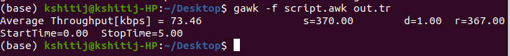

## Link state routing

### AWK script

BEGIN *{* recvd S i ze = 0

t x s i z e =0 drp Size=0 start Time = 0

stopTime = 0 thru=0

*}*

*{* event = $1 time = $2 node id = $3 p k t s i z e = $6 l e v e l = $5

# Store s t a r t time

i f ( l e v e l == ” rtProto LS ” && ( event == ”+” *| |* event == ” s ”) )

*{*

i f ( time *<* start Time )

*{*

start Time = time

*}*

t x s i z e ++;

*}*

# Update t o t a l re c e i v e d packets s i z e and s to re packets a r r i v a l time i f ( l e v e l == ” rtProto LS ” && event == ” r ” )

*{*

i f ( time *>* stopTime )

*{*

stopTime = time

*}*

recvd Si ze++

*}*

*}*

END *{*

#i f ( l e v e l == ” rtProtoDV” && event == ”d” ) #

#drp Size++ #d=%.2 f

*{*

#*}*

p r i n t f (” Average Throughput [ kbps ] = %.2 f t ts =%.2 f t tr=%.2 f Start Time=%.2 f tStopTime=%.2 f n ” , ( recvd S i ze /( stopTime−start Time +1 )) ,

*\ *

*\ \ \ *

tx s i z e , recvd Size , startTime , stopTime )

*}*

### Output

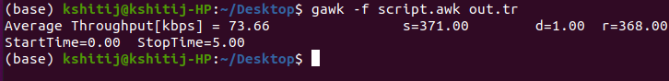

## Learning Outcomes

* Learnt how to implement distance vector and link state routing protocol
* Learnt how to analyse the simulation
* Learnt how to write TCL scripts for the simulation tool
* Learnt how to set up the appropriate topology, window size, and transmission rate to reduce congestion in the network based on the observations collected
* Learnt how to write awk script for evaluating performance of the protocol